The Omani Expulsion of Portuguese during the First Global Era (1450 – 1770 CE)
Author: Qusai Al-Mahrouqi

Overview and Purpose of the Lesson:
During the First Global Era 1440-1770 C.E, colonial European powers such as Great Britain, France, and Portugal were conquering massive swaths of lands, seizing numerous ports, and asserting control over the trade routes in the Indian Ocean. However, amongst the slew of victories by these colonial powers, one extraordinary case exists of a colonial defeat to a native power. The balance of power between these European colonial powers constantly shifted; however, these shifts were rarely because of a non-European actor. In the mid-17th century, the Portuguese were expelled from the Arabian Peninsula and much of the surrounding environs. After the election of Nasir bin Murshid Al-Ya'rubi as Imam of Oman in 1624, Oman was finally able to expel the Portuguese colonizer that had arrived over a century earlier. After expelling the Portuguese from Oman, Imam Nasir was able to chase the Portuguese fleet on the Indian Ocean and defeat them along the East African coast. Thereafter, with its sophisticated and capable navy, Oman became a bulwark against European machinations on the Arabian Peninsula and across Indian Ocean trade routes.
The objective of this lesson is to broaden the student's historical knowledge regarding colonialism in the Indian Ocean region. In addition, to share a rare example of a non-Western state overthrowing a colonial power. Colonial history has been most frequently written from the perspective of the Western colonial powers. This case study presents an outlier, a non-Western state defeating a Western colonial power. In the late 16th century, the Portuguese were declining as a major power in the Indian Ocean due to the rise of their European rivals, notably the Dutch and the British. Consequently, colonized states saw Portuguese decline as a vital opportunity to liberate themselves from the Portuguese rule. One of these colonies was Oman. Although Oman at the time was politically instable due to the clan clashes and power unrest, Oman was eventually unified when Imam Nasir bin Murshid established the state of Al Ya’arubahs in 1920. After the unification of Oman by Imam Nasir Murshid, Oman was finally liberated from the Portuguese rule in 1650. In addition to that, the Yoruba dynasty would rule Oman for almost a century and transform Oman into a regional power that ruled over portions of East Africa.
Performance Objectives.
- To understand the scope and methods of Portuguese colonial efforts
- To assess the Omani role in the Indian Ocean, both before and after the Portuguese expulsion
- To understand how the Portuguese were expelled from the Indian Ocean after they had dominated the trade routes in that region.
- To learn about the reasons behind the decline of the Portuguese in the Indian Ocean.
- To introduce students to Yarubi dynasty, which expelled the Portuguese from Oman.

Materials Needed:
· Access to the IOWH Website
· Handouts included in the lesson (one for each student)
· Projector/ whiteboard
Time: Two class periods (50 min each), one class period for each part
Class grade: 6- 12

Procedure:
Part I:
In part I, students will gain a familiarity with the Portuguese colonial empire in the 16th and 17th centuries and learn about their expedition voyages through the Indian Ocean during the First Global Era (1450-1770) CE. First, have the students read individually the following article, “May 20, 1498 CE: Da Gama Discovers a Sea Route to India”, which introduces them to the first Portuguese sailor to arrive to the Indian Ocean region, Vasco da Gama. https://www.nationalgeographic.org/thisday/may20/da-gama-discovers-sea-route-india/.
After reading the article on Vasco De Gama have the students watch the 3-minute movie clip below, which will broaden their knowledge regarding the history of the Portuguese empire between (16th-17th centuries):
https://www.the-map-as-history.com/Portuguese-and-Spanish-empires-16th-18th-centuries/Portuguese-overseas-trading-posts
After completing these background activities have students answer the questions in Handout A.
Finally, Project the First Global Era map from the (IOWH) Website such that the whole class can see it at one time. If this is not possible, assign students to look at it individually (in a computer lab or at home, etc.) and reconvene to share answers. Then, each student must complete, individually, Handout B.
While observing the map, students should:
- Be able to locate the trade routes from Europe to the Indian Ocean region.
- Look for Vasco da Gama’s icon and reflect on what they read in the National Geographic’s article about his biography.
- Locate the Cape of Good Hope in Southern Africa and learn its geographical importance to the Portuguese.
- Locate cities in which the Portuguese first settled in, such as Diu, where Portuguese built their first fort to protect them from the neighboring state of Gujarat.
- Students would locate traded goods with Europe brought by the Portuguese, such as spices and cloths from India and tea from China, as the Portuguese were the first Europeans to import tea from China
Questions to pose as students look at the map:
- Why did the Portuguese endeavor to find new trade routes from Europe to the Indian Ocean?
- Who was the first European sailor to reach the Indian Ocean coming from Europe through the Cape of Good Hope?
- Why the Cape Peninsula in Southwestern Africa was called the Cape of Good Hope?

Handout A Student name: Date:

From both the movie clip and the article on Vasco da Gama, answer the following questions with a short answer.

- What is “Estado da India?"

- When and where did Vasco da Gama first arrive in the Indian Ocean?

- Explain Goa’s trade and geographical role to the Portuguese colonizers?

- Why did Portugal send Vasco da Gama to India?

- How did Vasco da Gama sail to India from Portugal? Explain his route and its importance.

- Why did Europeans have a bad relationship with the Arab merchants in the Indian Ocean?

- How did Vasco da Gama’s expedition serve Portugal in regards to its trade and colonialism in the Indian Ocean?

Handout B Student name: Date:
In this handout you should locate, draw, and write the following on the map:
- Locate Portugal and it is capital city.
- Locate the main ports and cities which the Portuguese have used during the First Global Era using the icons from (IOWH) map. Why do you think these ports were vital to the Portuguese?
- Draw the sea trade route from Portugal to the Indian Ocean’s main ports and cities. Also, what do you think are some alternate trade routes from Europe to the Indian Ocean?
- Identify at least 4 Portuguese settlements on the map and mention their geographical significance?
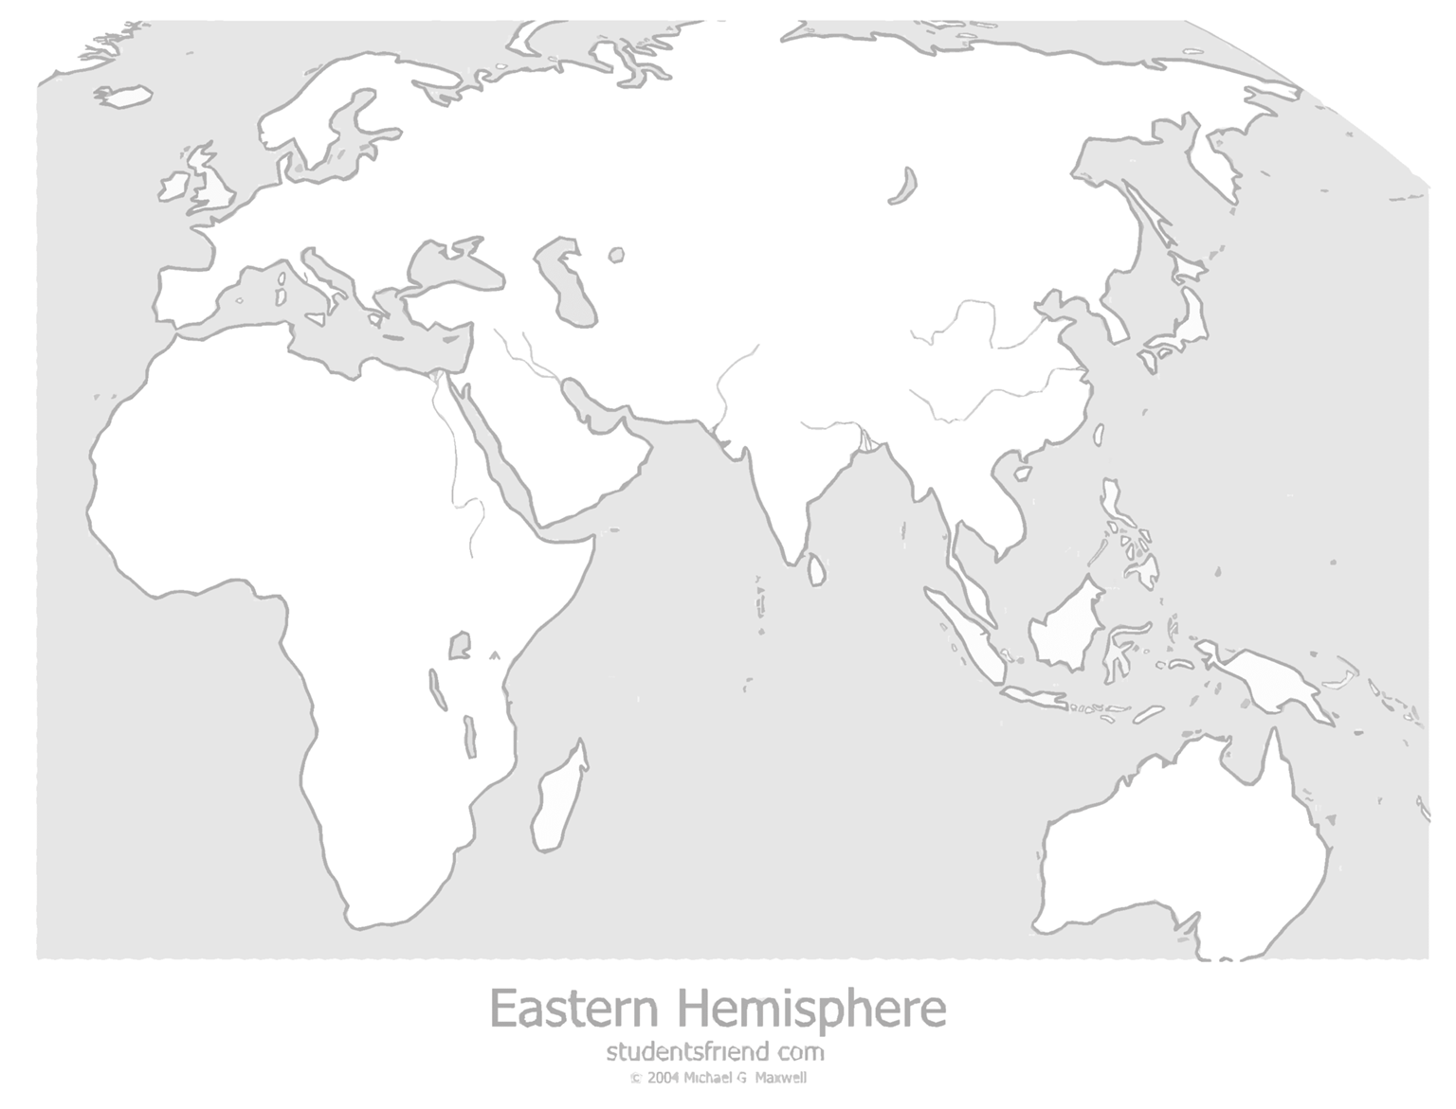

Part II:
In part II, students will learn about the decline of Portuguese settlements in the Indian Ocean during the 17th century. Students will gain familiarity with the chronological events and the reasons that led to their downfall. Moreover, students will explore the role of Yaruba dynasty in ousting the Portuguese settlers out of Muscat, Oman and the Arabian Peninsula. To do so, have the students, first, watch a video clip from minute (6:45 - 10:45). https://www.youtube.com/watch?v=QCto2bcL8-A
The clip demonstrates the decline of the Portuguese colonial power in the Indian Ocean while the Dutch and the British are ascendant. Thereafter, students should read Handout C individually. Handout C gives an overview of the rise of Yaruba dynasty in Oman. Simultaneously, it explores the chronological events, which led to the expulsion of the Portuguese settlers from Oman and the Arabian Peninsula. At the end of Part II have students answer questions in Handout D from their readings in Handout C.
After completing handout D, project the First Global Era map from the (IOWH) Website to the students to select related icons to the topic from the map such that the whole class can see it at one time. If this is not possible again, assign students to look at it individually (in a computer lab or at home, etc.) and reconvene to share answers.
While observing the map, students should pair in groups, each group consist of 3 students at least and discusses the following questions:
- Locate for the port city of “Muscat, Sultanate of Oman” icon and discusses its strategic importance to the Portuguese, how vital was Muscat to the Portuguese that made them conquer it for over a century?
- Look for the “United Dutch East India Company (VOC)” and assess its rise and how it affects the Portuguese decline in the Indian Ocean.
- Look for the “The Treaty of Tordesillas” icon and analyze it, what does the treaty states? what is it about? And finally, explore the reasons why it did not help the Portuguese in keeping their colonizes in the Indian Ocean from other European countries?

Handout C
Omani Expulsion of Portuguese of Oman in the 17th Century
The state of Ya’arubahs was established in Oman in 1624 CE (1034 AH) as a result of several circumstances, most notably the political instability of Oman towards the end of the Nabhani dynasty. As the fifteenth century CE drew to a close, the Nabhani state started to fragment into small states and entities. According to Omani sources, not all of the Nabhani era was marked by weakness, as there were indeed periods when Oman was governed by some great leaders, such as Falah bin Mohsin.
Nasir bin Murshid emerged as the first Imam of the state of Al Ya’arubahs, and was able to grasp all the dimension of the situation, with a good understanding of the developments both locally and regionally. He had realised that he would not be able to decisively confront the Portuguese, unless he was leaning on a tightly knit internal front, a goal that could not be achieved without ferocious wars to unify all Arab tribes in Oman. He had to start in the Al Rustaq Region, which was the cradle of his imamate. There he headed a group of his followers to the Al Rustaq Fort, which was under the command of his cousin, Malik bin Abi Al Arab Al Yarubi, and the Imam conquered it after a short siege.
In view of the heavy burden this task was placing on Imam Nasir bin Murshid, and in preparation for wars that could take longer than expected, he pursued a policy of building fortresses, or citadels, in the areas he entered. He would leave one of his followers to carry on the task of enforcing his principles and disseminating his messages, which spread smoothly through Oman; this era witnessed an increase in the influence of the Imam, in addition to his exemplary fairness that led the undecided to submit to his just power. His task was indeed made harder by the sheer number of kingdoms established on tribal grounds, to the extent of making it difficult to distinguish the tribe from the government. The elder (shaykh) of the tribe monopolised rule, and was called a king or an emir. The concept of one national state with a central administration was one with which the tribes of those days were unfamiliar.
One of the remarkable things about the Imam’s policy is that whenever he had achieved a degree of unity, he showed patience and waited for reactions that could avert wars. It gave his army the opportunity to regroup, reorganise, and inspect the recently conquered territory. Imam Nasir bin Murshid was thus able to achieve Omani unity with tenacity in his rule until 1649 CE (1059 AH). His attempts at unification sparked great hope in Oman, which the country had lacked for a long time. Imam Nasir bin Murshid was unique amongst the Ya’arubah Imams in tackling this problem on two fronts, inland and on the coast. At his death on April 23 1649 CE (Rabiaa Al Thani 1059 AH), the Omani tribes stood under one banner. The era of Imam Nasir bin Murshid was one the richest and busiest periods in the history of Al Ya’arubahs, and his efforts to achieve national unity provided the foundation for later victories against the Portuguese. Despite the fact that Oman had seen devastating civil wars from 1624 CE (1034 AH) until the death of Imam Nasir bin Murshid in 1649 AD (1059 AH), the country was eventually able to emerge stronger and more united, ushering Oman into a new phase of unity under a central government. It also brought to an end the age of division into small state entities under weak kings, who opted for ruling weak states instead of for the strength and unity of their country.
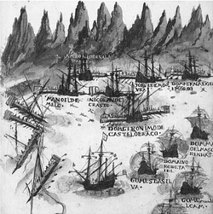
While Imam Nasir bin Murshid had achieved national unity, confronting the Portuguese presence on the shores of Oman required new resources beyond traditional means and resources used by the Al Ya’arubahs in ending the civil wars and establishing the authority of one unified state. All the wars fought by Imam Nasir bin Murshid took place on the ground, while the Portuguese were a seafaring nation. Their war techniques relied on ships and the industry of shipbuilding, which had made significant advancements since the beginning of their global explorations and expansion. Hence, their development of a colonial policy was based on the occupation of forts and citadels on sea routes, without going further inland. In 1643 CE (1053 AH), Imam Nasir bin Murshid captured the city of Suhar, and built a fort opposite the one held then by the Portuguese. Omanis also succeeded in acquiring a number of advanced ships, ammunition, and gunpowder from the English, which led to intensified military operations against Portuguese bases. The volume of English assistance to Oman overmatched the resources available to the Portuguese. As to the Al Ya’atibah, they fought in different circumstances and sought no help from foreign powers. Furthermore, at the time the Portuguese were ousted from Hormuz, Portugal was still subordinate to the Spanish Empire, so Omani efforts increased considerably after Portugal’s independence.
"The Portuguese attack on the Turkish fleet, in the Gulf of Oman"

Imam Sultan bin Seif came to power in 1649 CE (1059 AH), after the death of Imam Nasir bin Murshid. The new Imam immediately began preparations to end the Portuguese presence in Oman. He realized the importance of timing as a factor in inflicting the final blow, as he knew of a severe drop in the number of Portuguese soldiers in military campaigns in India. He also predicted that the death of Imam Nasir bin Murshid would cause the enemy to assume that the Omanis were weak, but Imam Sultan bin Seif only waited a few days before rushing into action. He used Towa Al Rola as a base for the all-out assault on the Portuguese. The Europeans, on the other hand, opted for high fortresses and walls where their soldiers could be positioned in order to aim their heavy guns in every directions. As an added precautionary measure, the Portuguese dug deep trenches around the walls and built a number of towers on the mountaintops surrounding Muscat and Muttrah. The battle between these two parties was fierce; the Portuguese could not match the Omanis in number, and the Omanis were unable to enter Muscat and Muttrah. Consequently, the battle raged for such a long time that Sultan bin Seif almost abandoned the siege, particularly when he learned that some tribes were considering withdrawing their support. By the end of 1652 CE (1063 AH), there were no Portuguese in the Gulf, except for their agency in Kang on the eastern shore of the Gulf. Nevertheless, the Portuguese did not give up hope of regaining control of the coast of Oman. They continued reinforcing their position in Kang, and even started negotiating with the Persians to establish a trading post in the island of Hengam. However, they failed to come to an agreement.

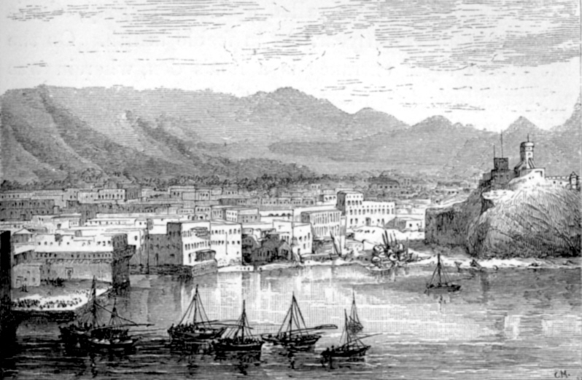
“City of Muscat”
The Omanis did not stop at ousting the Portuguese from their coasts, as they launched a series of land and sea assaults targeting Portuguese positions in the Indian Ocean. This included Bombay in 1661 CE (1072 AH), Dhio in November 1668 CE (Rajab 1079 AH), in January 1676 CE (Shawwal 1086 AH), and in 1670 CE (1081 AH), and Bassein in 1674 CE (1085 AH). Battles extended to the western Indian Ocean, where the two sides fought a long conflict over control of eastern Africa. The inhabitants of Zanzibar, linked to the Omanis by religion and national characteristics, had pleaded to Imam Sultan bin Seif to liberate them from Portuguese enslavement, but despite Imam Sultan bin Seif’s victories in the waters of Zanzibar, the Portuguese presence there endured until a strong Omani Navy was built by his son, Imam Seif bin Sultan. This established Omani control over the entire East African coast, from Mombasa to Kiluh. The Omanis brought under their control Pemba, Zanzibar, Patta, and Kiluh; Mozambique was the only land that resisted the Arab Omani fleet, and remained in the hands of the Portuguese until the twentieth century CE. The Portuguese tried to regain control over their lost territories, and launched an offensive on Zanzibar and Muscat simultaneously in 1729 AD (1142AH). However, the Portuguese sustained a terrible defeat that brought an end to all Portuguese hopes of restoring its influence in the Gulf and the Indian Ocean. Omani influence in the region was to extend from the South of the Arabian Peninsula to the East African coast in the West, to the shores of the Sind Valley in the East. Oman had started enjoying the status of "main trade distribution centre," and became one of the main ports on the Indian Ocean and the coasts of the Gulf in modern-day Iran and Iraq, as well as the Arabian Peninsula. Omani influence expanded westwards to the Great Lakes in Africa, and bordered the Gang Delta in the East.

Source: The Ministry of Foreign Affairs, Sultanate of Oman
https://www.mofa.gov.om/?p=760&lang=en

Handout D Student name: Date:

From the article on the Omani expulsion of Portuguese from Oman, answer the following questions in a short answer.

- Who is “Imam Nasir bin Murshid”? What role did he play in expelling the Portuguese?

- What is the Meinab Treaty? Why is it important?

- What was Sultan bin Seif strategy in fighting with the Portuguese?

- Which cities did the Omanis expell the Portuguese from?

- From Handout C, and after learning from Part II. Indicate and explain the reasons, which you think, led to the downfall of the Portuguese empire in the Indian Ocean?

